

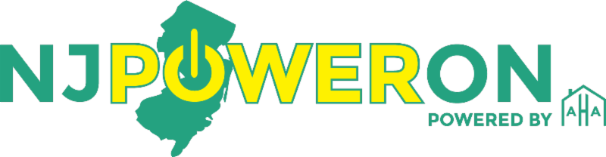

Are you or someone you know struggling with utility bill payments?

Apply for the TRUE and PAGE programs TODAY


Affordable Housing Alliances (AHA) realizes that this may be a challenging year for many households in our service community. Winter heating costs can be one more burden to a family in financial distress. If your household has suffered a financial hardship or temporary emergency that has caused you to fall behind on your electric and/or gas bills, help is available.

The New Jersey Board of Public Utilities (BPU) has provided funding to AHA for a two grants, both intended for low- to moderate-income New Jersey residents who are struggling to pay their electric and natural gas bills. They are the Payment Assistance Gas and Electric (PAGE) Grant and the Temporary Relief for Utility Expense (TRUE) grant. Customers may benefit from both programs in a 12-month period for combined assistance towards their past due bill. Up to $750/utility is available under each program. Same application is used for both programs. Customers must:

- Have a utility bill that is currently past due or have a payment plan to pay your back due bills.
- Have made at least two payments of $25 or more in the last six months. At least one of those payments should have been made within the past 15 days, or a $75 good faith payment should have been made within the last 90 days.
- Must not currently be applying for, receiving or have received any benefit through the LIHEAP programs within the current heating season. Must not currently be receiving a USF benefit.
- Meet annual income requirements listed in the chart below

Household Size | 1Person | 2Person | 3Person | 4 Person | 5 Person | 6 Person | 7 Person | 8 Person | 9 Person
Min. Annual Income | $23,556 | $31,872 | $40,200 | $48,516 | $56,832 | $65,160 | $73,476 | $81,792 | $89,436
Max. Annual Income | $54,963 | $71,877 | $88,788 | $105,700 | $122,612 | $139,525 | $142,695 | $145,867 | $149,038
For more information or to apply online, visit www.njpoweron.org or call 732 982 8710

Sincerely,
Utility Assistance Department
Affordable Housing Alliance

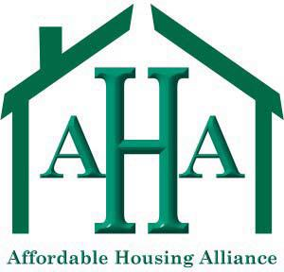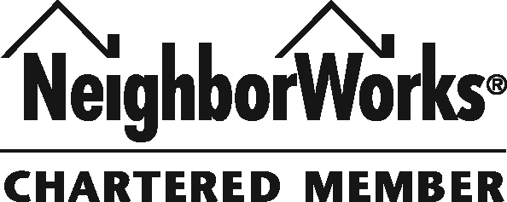

Know someone else that would be interested in our organization?

SHARE THIS EMAIL

Not yet signed up to receive our informative emails?

SIGN UP

